Here’s the circuit I built:
(show sketch)
Note that it wasn’t blinking yet. That’s because there’s no power supply. The microcontroller will become the power supply once we give it power.
We should talk a smidge more about microcontrollers. Grandpa taught me a lot that day and you’ll need to learn all this stuff too.
This is an Arduino-compatible microcontroller based on the Arduino Uno.
(sketch)
You say it like this: Are – Du – Eee – No.
It’s an Italian word.
A microcontroller is a miniature computer that does a specific job within a larger machine or system. Microcontrollers are everywhere these days. All the so-called “smart” devices in our lives are smart because of these miniature computers inside of them.
In 2005, an Italian company named Arduino started making an inexpensive, multi-purpose microcontroller that anyone could use to build anything they wanted to build, and in 2010, they introduced the Arduino Uno, which became their most popular design for a long time after that. Even today, all these years later, the Arduino Uno is still widely used by makers all over the world whenever they want to build something cool that needs a little electronic brain inside of it.
Like, say, a robot.
One brilliant thing Arduino did: they made their designs open source. That means they said, “Hey world, here’s how we built it. Copy us if you want.” This meant people everywhere could make their own Arduino-compatible microcontrollers, keeping them cheap and widely available.
If it’s made by Arduino, we call it an Arduino.
If it’s made by someone else using Arduino’s open-source design, we call it Arduino-compatible.
(sketches of Arduino and Arduino-compatible microcontrollers)
Open source is a pretty awesome thing, and because of it, quietly, there are Arduinos and Arduino-compatible devices everywhere. They’re in labs, in garages, and in factories. Scientists and engineers use them to test ideas. Tinkerers use them for homemade gadgets. Teachers use them all the time to teach the basics of electronics, robotics, and embedded systems.
But in order to make a microcontroller work, you have to program it.
And in order to program it, you need a kind of software called a development environment.
“The first thing we need to do is download the Arduino IDE from the Arduino web site,” Grandpa said.
IDE stands for Integrated Development Environment — a fancy way of saying ‘a program for writing computer programs.’ You’ll see it written as Arduino IDE. But say each letter: Arduino I – D – E. Don’t say Arduino I’d. In fact, if you hear someone say I’d rather than saying every letter (I – D – E), it is your solemn duty as a programmer to immediately reply, “I’d like an egg salad sandwich.”
I decided it was okay to break my No-Internet Rule when Grandpa asked me to go online and download the Arduino IDE.
“Go to arduino.cc and navigate to products then software,” Grandpa told me.
I brought up this web site.
(screenshot https://www.arduino.cc/en/software/)
I downloaded and installed the Arduino IDE. It took less than a minute.
When I opened it, the screen looked like this:
(screenshot Arduino IDE first screen)
“When you built your first circuit, you had a battery power the LED,” Grandpa said. “But now the microcontroller will power it.”
“So it works like a battery?”
“Providing power is just one of many things the microcontroller can do,” Grandpa said. “For this first circuit, the microcontroller will get power from your computer through the USB cable, and it will power the LED.”
“So all I have to do is plug it in?” I said.
“Try and and see,” said Grandpa.
I used a USB cable to connect my microcontroller to my laptop.
A tiny green light on the microcontroller came on, buy my circuit remained dark.
(sketch)
“It’s not working.”
“You haven’t told the microcontroller what to do,” said Grandpa.
“Ahh…I need to program it.”
“Good. Program it to do what?”
“Make the LED turn on and off,” I said.
“That’s still too vague. Computers need precise instructions.”
“I need to tell it to send electricity on and off,” I said.
“Right, and since you connected the LED’s positive leg to Pin 13, you’ll tell Pin 13 to send pulses of electricity to the LED blinks.”
“I’m about to write a computer program?”
“You are,” said Grandpa.
I don’t know if you’re like me, but I’ve always thought programming computers sounded like a superpower. I’ve always wanted to learn, but I’ve never known how to start.
I’m going to show you the exact program Grandpa helped me make that day.
Here’s the exact program Grandpa helped me write that day. You’ll learn what every line does later, but for now, type it in exactly and see if you can guess what it’s doing as you go.
(screenshot of blink code)
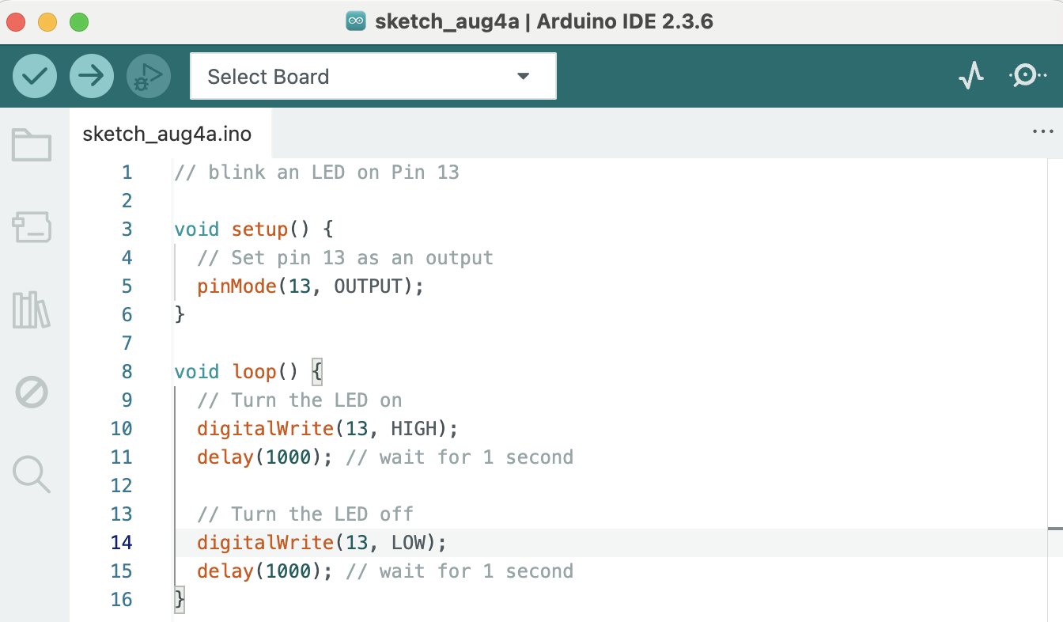
“Alright, I’ve typed it in,” I said. “Now what?”
“Now we load the code onto the microcontroller,” said Grandpa.
I clicked the dropdown menu at the top of the screen and selected my board. (yours might say Arduino Uno or COM3)
(screenshot)
In the top left, there are two buttons: a checkmark and an arrow. Hover over them and you’ll see:
- Check = verify your code for errors.
- Arrow = upload your code to the board.
(screenshot with captions)
I clicked the checkmark. No errors!
(Note: If you do get errors, congratulations! You’re a real programmer. Programming is mostly fixing mistakes. If you’re stuck, go to gavinholloway.com and watch the video called Blinking an LED.)
One more step needed to load the program on the microcontroller. Take a guess what it is.
Right! We need to press the arrow button.
(show screenshot)
Do you notice something happening that maybe wasn’t happening before?
(show sketch entire circuit).
Does yours blink?
Mine did. And when it did, I stared at it like I’d just discovered fire. I just sat there, stunned, grinning, watching that tiny blinking light and realizing for the first time that I could tell a machine what to do, and it listened.
As soon as you get yours working, you should allow yourself a moment of joy as well, because it is kind of a big deal.
You just programmed a microcontroller and built it into a circuit.
That’s totally how people build robots.

